Parallel and Inverse Analysis
Parallel and inverse analysis is the study of how individual currencies influence the movements of currency pairs and their intraday movement cycles or within the context of a trend. It has also been called currency correlations and individual currency analysis. Few if any, forex traders understand these concepts and essentially nobody is educating traders on this subject. However forex trading success would skyrocket if forex traders would master these concepts. Parallel and inverse analysis of the spot forex can be learned in about two weeks by any forex trader at any level.

Eight Major Individual Currencies
Here are the are eight most widely traded individual currencies in the spot forex that we will examine in this knol.

- USD US Dollar
- CHF Swiss Franc
- EUR Euro
- GBP British Pound
- JPY Japanese Yen
- CAD Canadian Dollar
- AUD Australian Dollar
- NZD New Zealand Dollar

Please note that an individual currency is not a currency pair, it seems very simple and fundamental but it is the crux of this entire technical paper and essential to learn forex trading. Remembering that a currency pair is comprised of two separate currencies will open your eyes to the pips.
Parallel and Inverse Pair Grouping Examples
An example of a parallel group of currency pairs is as follows:

- EUR/USD
- EUR/JPY
- EUR/CHF
- EUR/GBP
- EUR/CAD
- EUR/NZD
The EUR is on the left in all pairs and is the common individual currency.
An example of parallel and Inverse group of pairs is as follows:

- GBP/CHF
- EUR/CHF
- USD/CHF
- CHF/JPY
The CHF is on the right on three pairs but on the left on the CHF/JPY, the CHF is the common individual currency. This occurs on other currency pair groups. These are the very basics to learn forex and parallel and inverse analysis.

Basic Discussion of How and Why Currency Pairs Move
First example:
If the EUR/USD is rising and the USD/CHF is falling
then the USD weakness is controlling and "driving" the movement of both pairs, the USD is weak.
Second example:
If the EUR/USD is rising and the USD/CHF is also rising
then the USD is not controlling the movement. The EUR's strength is causing the EUR/USD to move higher and the CHF's weakness is causing the USD/CHF to rise.
In this case the EUR is strong and the CHF is weak so the best pair to trade would be to buy the EUR/CHF. The USD is completely out of the picture in the second example as far as what was driving the movement of the market.
These are two of the most basic examples. Not knowing this basic information represents the biggest failing of forex traders worldwide. Although this relationship between pairs and the real reasons for their movement being the movements of the currencies is simple and basic it escapes nearly every trader, although the logic is incredibly clear.

This simple, basic logic works for about 25 currency pairs derived from the eight most widely traded individual currencies in the spot forex and can generate 500 to 1000 pips of forex trading profits in a single week of trading.
One more example using different pairs and currencies but the same logic.
If the AUD/USD is rising and the USD/CAD is falling
then the USD weakness is controlling and "driving" the movement of both pairs, the USD is weak.
But if both of these pairs are rising then the USD is not controlling the movement and the best pair to trade would be to buy the AUD/CAD. This is the same logic as the first two examples above but this time we are using different pairs and currency groups.

Once again, each currency pair has two individual currencies, by looking at other currency pairs in the same groups of pairs you can quickly determine what is driving the movement. In the case of the AUD/USD and USD/CAD example they are either moving in the same direction or opposite directions, or on some trading days not at all.
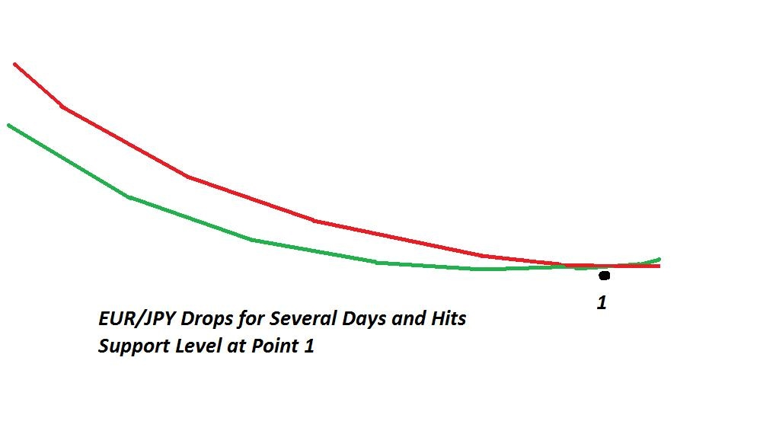
In this example above the EUR/JPY has been dropping for several days based on some simple trend indicators like exponential moving averages. There is a link at the bottom of this knol to a set of simple trend indicators like these. You can check several EUR pairs or several JPY pairs over the same time period and quickly determine if the downward movement on the EUR/JPY over this time period was based on EUR weakness or JPY strength, or possibly both.
If the EUR/CAD, EUR/GBP, EUR/USD and EUR/CHF are all falling over the same time period then EUR weakness is driving the movement over this cycle. If the GBP/JPY, CAD/JPY and AUD/JPY are all falling over the same time period, then the JPY strength is the reason that the EUR/JPY dropped. This is incredibly simple but ignored by almost all forex traders.
Next the EUR/JPY stalls at support, Point 1 on the example chart. If it reverses back to the upside at Point 1 once again checking a few pairs will quickly tell you if EUR strength or JPY weakness is driving the EUR/JPY back up.

Now apply this logic to any currency one of 25 currency pairs comprised of the eight major currencies and you will almost immediately start to understand why currency pairs move and you will almost immediately start to get many more pips out of your trading using the basic individual currency movements. This forex market logic presents itself daily to forex traders but almost no forex traders notice. The forex indicators and systems available now to forex traders do not take this simple logic into account and these systems are all fundamentally flawed.

Using Parallel and Inverse Analysis to Analyze The Forex Market
Now that we know the basics about parallel and inverse analysis lets move into some new concepts.
When you analyze the forex market always analyze currency pairs as a group, by individual currency, not individually as a single pair. Currency pairs are not an island. Analyze all of the USD pairs together, then analyze all of the JPY pairs together, then analyze all of the CAD pairs together, etc. The trends of the market, oscillations and consolidation cycles will jump out at you right off of your charts and into your lap. If a particular group of pairs are all behaving the same way the market becomes a lot easier to trade. It is also very easy to spot choppiness or a more difficult market and you may consider not trading at all today, and with good reason.

Getting forex traders to do it this way is nearly impossible. But it is imperative to analyze pairs carefully. Doing so will allow you make better decisions as to when to trade and it will make a lot more sense as to why you should stay in your trades. For example, if you buy the AUD/CAD and the AUD/JPY and AUD/USD are also trending up, its a lot easier to make an effort to stay in the trade for a longer period of time based on overall AUD strength. This concept works for any pair and that's why the method is solid.

Here is an example of how to correctly use parallel and inverse analysis to analyze the condition of a particular currency pair. For example if you would like to conduct an analysis of the USD/CHF, you would first conduct an analysis of several USD pairs using multiple timeframe analysis. Conduct multiple timeframe analysis of the USD/CHF then repeat the analysis on the EUR/USD and GBP/USD, at a minimum. You would be looking for consistent strength or weakness, trends, oscillations, or movement cycles in the USD. In the event that there is no agreement in the 3 USD pairs you could also conduct an analysis of the GBP/CHF and EUR/CHF looking for consistent trends and movement cycles based on CHF strength or weakness.
By analyzing the USD and then the CHF you have completed your analysis of the USD/CHF. Is this what forex traders do?? No they don't, but it works and it works on any pair any day the forex market is open. Then you would know for sure whether or not the USD/CHF is trending or oscillating and whether the reason was USD strength or weakness or CHF strength or weakness, then you have done the analysis correctly and thoroughly. Most forex traders will not do this and most forex traders are not thorough. They want something that's quick like forex robots or forex news trading and they subsequently lose money. But doing it this way is totally logical and starts to reduce or eliminate entry risk of forex trades.

For a full discussion of multiple timeframe analysis of a currency pair please check the links to my other knols on the right side of this page and also at the bottom of this knol. At the bottom of this Knol is a link to a set of trend indicators for multiple timeframe analysis.

How Currency Pairs are Constructed
This section is incredibly basic but almost every forex trader is completely blind to it. It is a major failing of almost every forex trader.
Most forex traders treat a currency pair like a single unit, or an island in the forex market. This is a huge error and almost every forex trader does this. They take a currency pair like the EUR/USD and treat it as a single thing, single object or single unit, which is a major and a massive mistake. This is not only a mistake but also a complete fallacy and a complete falsehood that leads to consistent failure.
The EUR/USD is composed of two individual currencies each with their own separate behavior, fundamentals, current condition, news releases, and reasons for moving up and down. In order to analyze the EUR/USD you must analyze the EUR currency separately and the USD separately.
Look at it this way:
EUR/USD
or this way which is more accurate
EUR & USD
This visual should tell you how to think about separating the two currencies in any pair for individual analysis.
The EUR and USD are two separate currencies that can both be weak, both be strong, or both be moving in opposite directions at any time in a trading session or within the context of the current market trends. I have tried and hopefully succeeded in proving this so far and especially in the section about market analysis just above this section.
The sum of the parts equals the whole and 1 + 1 equals 2 in the forex. The minute you start to treat the EUR/USD as a single unit you have failed before you ever started trading. The minute you start to view the EUR/USD as two separate currencies and analyze each currency separately then you not only have a chance to succeed with forex trading, but pips will begin to fall in your lap with some information that is obvious and incredibly basic but completely overlooked by almost all forex traders.
Now you can apply this same logic to any currency pair, it works.

Individual Currency Strength and Weakness
Now that you know how a currency pair is constructed lets investigate further.
Almost all forex traders apply technical indicators to currency pairs, after you read this section of the knol you may never do it again or you will at least wonder why you ever did it in the first place. I have literally seen forex traders take every technical indicator off their computer and charting system after realizing that what you are about to read below is true.
Back to the EUR/USD again. If you buy the EUR/USD the only way it will rise is if the EUR as an individual currency is strong or the USD as an individual currency is weak or both. The best scenario is both because the EUR/USD will appreciate the fastest under these conditions. This is also true if you buy Euros with US dollars at a currency cashier or buy the EUR/USD online with US dollars. It works the same way.
Buying the EUR/USD implies buying the left (base) currency and selling an equivalent amount of the right (quote) currency to pay for the base currency. For example, buying EUR/USD means that you are buying Euros and using US dollars to make the buy, or selling US dollars.
This concept must be fully understood or your forex journey will be short and you will "blow up" account after account and not know why. Technical indicators do not take individual currency strength or weakness into consideration. They never have and they never will and we have difficulties seeing how any technical indicator could work at all except for scalping. Scalping is not trading, scalping is scalping, and there is not a forex trader alive who will admit that they enjoy it.
There are over 150 technical indicators and over 100 candlestick chart types available to forex traders. But indicators do not drive movement on a currency pair. The only thing that drives movement on a currency pair is the currency strength or weakness of the two individual currencies that are in the pair, that's it, that is all, nothing else. In this regard technical indicators are somewhat worthless because none of the 250 indicators can measure this. Technical indicators are applied to pairs not individual currencies, and that's the failure point.
An analogy is this, the only way a car can move is if you step on the gas pedal, this is what actually causes the car to move. Individual currency strength and weakness is the gas pedal for a currency pairs, this is what makes them move. Technical indicators do not make currency pairs move they just "indicate." Indicators are nothing more than drawings on your computer screen.
Since technical indicators are applied to currency pairs, not individual currencies, people who use them are 99% likely to fail. The failure rate of forex traders is incredibly high and now everyone can see why.
I strongly suggest that forex traders start using parallel and inverse analysis to analyze individual currency groups, and individual currency pairs. Traders can also use parallel and inverse analysis of individual currencies also at the point of trade entry in lieu of technical indicators. This is the entire method and rationale presented here.
The entire forex industry is "steeped" in technical indicators and forex robots based on these technical indicators and slowly forex traders are getting fed up with all of this and looking for viable alternatives with credible logic behind them. These technical indicators originally migrated over from the stock market, and stocks in no way behave like currency pairs nor are they constructed like currency pairs.

Trends in the Forex Market
An intermediate or longer term trend can be created by the day to day dynamics of the forex market. As an example lets say that the USD/JPY is consolidating sideways then starts an intermediate to long term uptrend and continues through that trend for a few weeks or a few months.

Throughout the course of the trend the movement drivers could be the USD strength or the JPY weakness on a day to day basis because the market dynamics can change day by day. In between the movement cycles the pair consolidates or retraces.

Almost no forex trader can explain what a trend really is on the forex, even people who claim to be a trend trader. This is because they do not understand parallel and inverse analysis. A trend on a currency pair is nothing more than a long series of continuous market dynamics on both sides of the pair that favors movement in one direction. In order for the USD/JPY to build a trend that lasts for several weeks either the USD must be weak or the JPY must be strong or both throughout most of the period.

If you analyze the forex charts of other USD pairs or other JPY pairs during the period of time when the USD/JPY is trending at least one of those groups will be trending in the same direction. Parallel and inverse analysis wins again with obvious, simple and logical analysis. It wins every time because it is the logic behind the spot forex. Learn parallel and inverse analysis and you will learn to clearly identify and capture pips from forex trends.
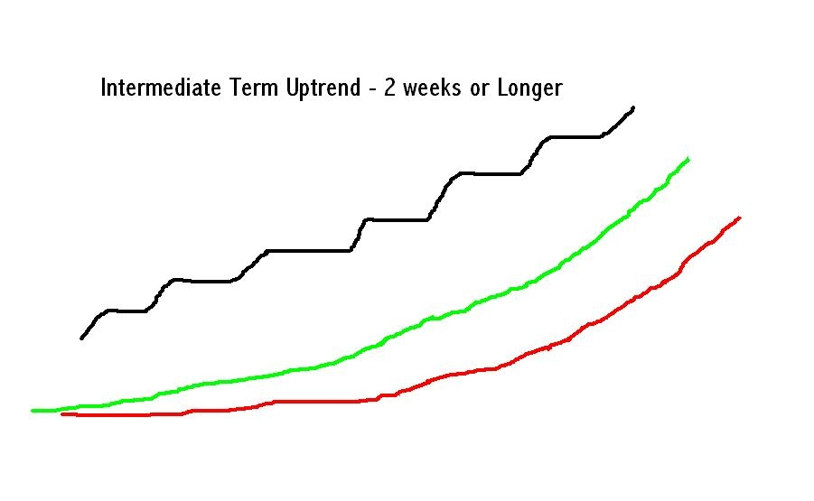
This picture depicts a longer term uptrend on the USD/JPY using simple trend indicators like exponential moving averages. The black line represents the movement cycles and consolidation cycles on a conventional price chart. Each individual up cycle within the trend is either USD strength or JPY weakness or both. Nothing else. It's that simple.
Remember that a trend on a currency pair is a long series of movements and market dynamics on both sides of the pair that favors movement in one direction.

Ranging and Choppy Markets
We just finished discussing trend and what drives a trending market or pair or group of pairs, now let's discuss a totally different type of market, a ranging or choppy forex market.
Once again parallel and inverse analysis comes to the rescue. You now have some new thoughts and ideas as to how to spot a choppy market or choppy group of pairs using parallel and inverse analysis methods.
Generally speaking a ranging market can take on two forms. Currency pairs ranging up and down in large oscillations that are easy to spot and trade. Or tight ranging choppy markets that are so difficult to trade that it's best to walk away. In a tight ranging market the drivers (market dynamics) change almost daily. One day the AUD is strong the next day the CAD is weak and the next day the USD is strong, etc., and it just continues for days and days. In a trending market the market dynamics change less frequently.

In a choppy market the individual currencies driving the movement change much more frequently or almost daily. Once again each currency pairs has two sides, so either side of the pair can be driving the movement. If you can identify what parallel and/or inverse group is driving the market you can successfully trade every day. When do the market drivers switch??? They switch drivers during the intraday consolidations that generally occur after the USD session.

If you are interested in buying or selling a particular currency pair and you read how to properly analyze the forex market in this knol you will spot a difficult to trade choppy market rapidly. If you are stuck analyzing the same currency pair day after day you will be ignorant of the market condition that exists on the same group of parallel and inverse pairs. This ignorance will result in stop out after stop out and you will never ascertain why the stop outs are occurring. The reason is a lack of market information which is clearly visible in a set of forex charts or forex trading software sitting on your desktop. You must look at the market deeper.
Conversely identifying a trending market will become much easier as well. This is why all forex traders should review the condition of as many currency pairs as possible in your day to day market analysis routine in the same parallel or inverse families that you are interested in trading. Once again the concepts of multiple timeframe analysis and drilling down the timeframes is the method we prefer.
You may not even trade some of the pairs you analyze but you will know what is going on in the market. As a trader that is your job, to know the condition of the market by examining the forex charts systematically to assist with your forex trading and entries.

Using Parallel and Inverse Analysis at the Point of Entry
Now that we know why pairs move and how to use parallel and inverse analysis to analyze the spot forex, we can now apply this knowledge to trade entries.
The number one question forex traders have is 'When do I enter??," quite naturally.
Once again parallel and inverse analysis will solve this problem. Entry management with parallel and inverse analysis is another application. After you analyze the market and you write a trading plan, then set your price alarms (see my knol on support and resistance and price alarms), when the alarms go off, parallel and inverse analysis can be used for entry management. Forex traders need to know when to get in, when to stay out, and when to look at another pair. They need an entry management tool that verifies the trade entry.

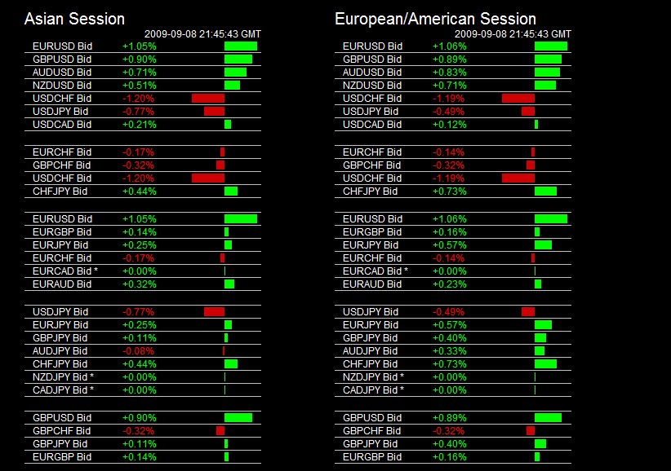
This tool is called The Forex Heatmap (tm) and it tells you which individual currencies are strong and weak in real time, it tells you what pair to enter and in what direction across 25 pairs. It's basis is technical indicators.

Throughout the trading week sometimes you can get a “slingshot effect” when a currency pair has a dual driver, one individual currency is strong and the other is weak. Here is an example….If the EUR is strong across the board (all EUR pairs are green on the heatmap) and the JPY is weak across the board (all JPY pairs are green on the heatmap again) the EUR/JPY will “slingshot” and move higher at a much faster rate. A pair with the volatility level like the EUR/JPY will move pair at least 150 pips under these conditions. Trading with technical indicators is no longer necessary.

For a step by step guide to using the Forex Heatmap (tm) see the link at the bottom of this Knol.

Summary and Conclusions
The vast majority of forex traders, almost all of them, don’t even know what parallel and inverse analysis is, much less understand it or use it daily in their trading. I am asking all forex traders to become experts at parallel and inverse, and use it to analyze the market and at the point of entry. Forex traders will never realize the real profits of the market until they become experts at parallel and inverse analysis, it drives the movement in the entire market every day. Technical indicators and the forex robots based on the same technical indicators are highly suspect and forex traders want and need alternatives that work to produce pips.

Thorough knowledge of parallel and inverse analysis will permanently change the way you think about the forex and why currency pairs move.

List of Important Links
Knol for Multiple Timeframe Analysis
Link to Free Trend Indicators for Multiple Timeframe Analysis
Link to The Forex Heatmap
Link to The Step By Step Guide to Using The Forex Heatmap
Link to Forexearlywarning We use Parallel and Inverse Analysis Every Day
Link to Slideshow on Slideshare

